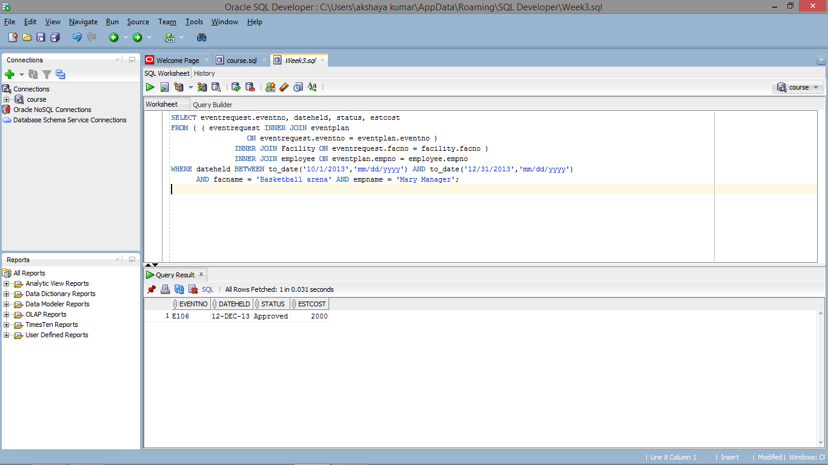

SELECT eventrequest.eventno, dateheld, status, estcost

FROM ( ( eventrequest INNER JOIN eventplan

ON eventrequest.eventno = eventplan.eventno )

INNER JOIN Facility ON eventrequest.facno = facility.facno )

INNER JOIN employee ON eventplan.empno = employee.empno

WHERE dateheld BETWEEN to_date('10/1/2013','mm/dd/yyyy') AND to_date('12/31/2013','mm/dd/yyyy')

AND facname = 'Basketball arena' AND empname = 'Mary Manager';